PROJECT REPORT

DBMS

Submitted By:

Sheenam Gupta

Elizabeth Joseph

Amandeep Kaur Sidhu

USE CASE DIAGRAM

Admin

User

School

Authority

ERD (Barker’s Foot Notation)

SPECIALIZATION

#SP_Id

*SP_Name

SCHOOL

#School_Id

*School_Name

*School_Type

*School_Category

*School_Address

*D_Id

DIVISION

#D_Id

*D_Name

has have

belong to comes under

TEST

#Test_Id

*Test_Name

*School_Id

*Max_Mark

*Test_Date

conduct

conducted by

contains recieves

submitted to

PREFERENCE

#PR_Id

*App_Id

*PR_No

*School_Id

O Status

APPLICATION

#App_Id

*F_Name

*L_Name

O M_Name

*Dob

*Address

*Pin

*Phone

O Email

*App_Date

O Final_Status

o Remark

*D_Id

linked with

MARK

#Test_Id

#App_Id

*Mark

has

associated

with

Relational Schema

DIVISION (D_Id, D_Name)

SCHOOL (School_Id, School_Name, School_Type, School_Category, School_Address, Pin, Phone, Email, D_Id)

SCHOOL_TYPE (ST_Id, ST_Name)

SCHOOL_CATEGORY (SC_Id, SC_Name)

SPECIALIZATION (SP_Id, SP_Name)

SCHOOL_SPECIALIZATION (School_Id, SP_Id)

APPLICATION (APP_Id, F_Name, L_Name, M_Name, DOB, Address, Pin, Phone, Email, App_Date, FinalStatus, Remarks)

PREFERENCE (APP_Id, Pref_No, School_Id, SP_Id, Admission_Status)

TEST (Test_Id, School_Id, Test_Name, Total_Marks, Test_Date)

Test_Mark (Test_Id, App_Id, Mark)

**Note: Blue color represents the primary key**

**Green color represents the foreign key**

**Red color represents the composite key**

Queries

**A Query that uses ORDER BY:**

**This query will return the name, concatenated address, phone number and email address in alphabetically descending order of school name:**

SELECT SCHOOL_NAME AS SCHOOL, SCHOOL_ADDRESS||','||SCHOOL_PIN AS

ADDRESS, SCHOOL_PHONE AS PHONE, SCHOOL_EMAIL AS MAIL

FROM SCHOOL

ORDER BY SCHOOL_NAME DESC;

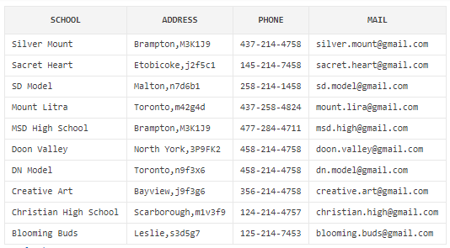

**A Query that uses INNER JOIN:**

**This query will return the detailed information about table from four different tables:**

SELECT S.SCHOOL_NAME AS SCHOOL,S.SCHOOL_ADDRESS||','||S.SCHOOL_PIN AS ADDRESS,S.SCHOOL_PHONE AS PHONE, S.SCHOOL_EMAIL AS MAIL,ST.ST_NAME AS TYPE,SC.SC_NAME AS CATEGORY

FROM SCHOOL S INNER JOIN SCHOOL_TYPE ST ON S.ST_ID=ST.ST_ID

INNER JOIN SCHOOL_CATEGORY SC ON S.SC_ID=SC.SC_ID

ORDER BY ST.ST_NAME,SC.SC_NAME;

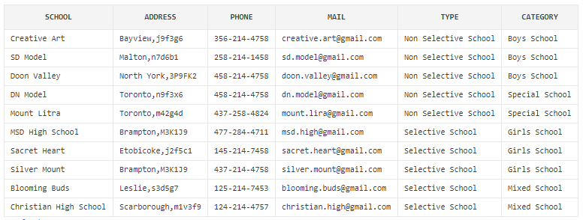

**A Query that uses aggregate functions:**

**This query will return the total number of applications for each school in descending order:**

SELECT S.SCHOOL_NAME||', '||S.SCHOOL_ADDRESS AS SCHOOL,COUNT(*) AS NO_OF_APPLICATIONS

FROM PREFERENCES P INNER JOIN SCHOOL S

ON P.SCHOOL_ID=S.SCHOOL_ID

GROUP BY S.SCHOOL_NAME,S.SCHOOL_ADDRESS

ORDER BY NO_OF_APPLICATIONS DESC

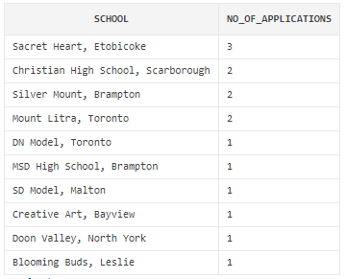

**A Query that uses GROUP BY and HAVING clauses:**

**This query will return the name of the school which received the highest number of applications:**

SELECT S.SCHOOL_NAME||', '||S.SCHOOL_ADDRESS AS SCHOOL,COUNT(*) AS NO_OF_APPLICATIONS

FROM PREFERENCES P INNER JOIN SCHOOL S

ON P.SCHOOL_ID=S.SCHOOL_ID

GROUP BY S.SCHOOL_NAME,S.SCHOOL_ADDRESS

HAVING COUNT(*)=(SELECT MAX(COUNT(SCHOOL_ID)) FROM PREFERENCES GROUP BY SCHOOL_ID)

ORDER BY NO_OF_APPLICATIONS DESC

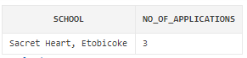

**A Query that uses a sub-query as a relation:**

**This query will return the marks of every test of a particular student by providing the applicant id:**

SELECT S.SCHOOL_NAME SCHOOL,R.TEST_NAME EXAM,R.TEST_DATE,A.FNAME||' '||A.MNAME||''||A.LNAME NAME,R.MARK SCORED,R.TOTAL_MARK MAX_MARK

FROM SCHOOL S INNER JOIN (SELECT T.*,TM.APP_ID,TM.MARK

FROM TEST T INNER JOIN TESTMARK TM

ON T.TEST_ID=TM.TEST_ID) R ON S.SCHOOL_ID=R.SCHOOL_ID

INNER JOIN APPLICATION A ON R.APP_ID=A.APP_ID

WHERE R.APP_ID=1

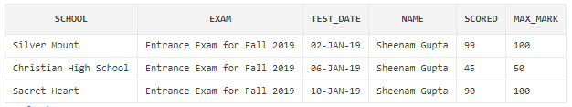

**A Query uses a sub-query in WHERE clause:**

**This query will update the admission status of applicant’s preference based on the school id and available seats in that school. (We supposed school id=101 has total 20 seats for admission)**

**Additional Note: Non-selective schools give admission based on FCFS bases and selective school will give admission based on test marks of the applicant)**

UPDATE PREFERENCE SET ADMISSION_STATUS='CONFIRMED'

WHERE APP_ID IN

(SELECT APP_ID

FROM (SELECT P.APP_ID,P.SCHOOL_ID

FROM APPLICATION A INNER JOIN PREFERENCE P ON A.APP_ID=P.APP_ID

WHERE P.SCHOOL_ID=101

ORDER BY APPLIED_DATE)

WHERE ROWNUM<=20) AND (SCHOOL_ID=101)

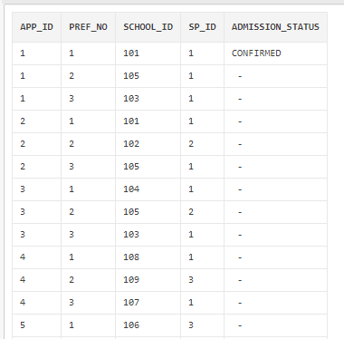

**A query stored as a VIEW**

**This query will create the view of the applicant detail**

CREATE VIEW ApplicantsInSameDivision AS  
SELECT APP_ID,FNAME||' '||MNAME||' '||LNAME AS NAME,DOB,ADDRESS,PHONE,EMAIL  
FROM Application  
WHERE  App_Div_Id=1;

SELECT * FROM ApplicantsInSameDivision

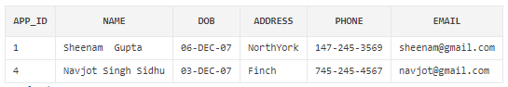

**View as a relation**

SELECT COUNT(*) AS NO_OF_APPLICATIONS  
FROM PREFERENCES WHERE SCHOOL_ID=101  
AND APP_ID IN (SELECT APP_ID FROM ApplicantsInSameDivision) AND PREF_NO=1

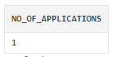

**A query that uses partial matching in the WHERE clause**

SELECT APP_ID,FNAME||' '||MNAME||' '||LNAME AS NAME,DOB,ADDRESS,PHONE,EMAIL  
FROM Application  
WHERE  FNAME LIKE 'E%';

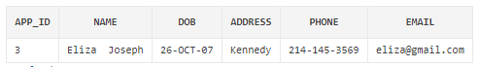

**A query that uses a self-JOIN**

SELECT A.FNAME||' '||A.MNAME||' '||A.LNAME AS  
NAME,A.DOB,A.ADDRESS,A.PHONE,A.EMAIL,S.SCHOOL_NAME,P.PREF_NO  
FROM PREFERENCE P INNER JOIN APPLICATION A ON P.APP_ID=A.APP_ID  
INNER JOIN SCHOOL S ON P.SCHOOL_ID=S.SCHOOL_ID  
WHERE SP_ID=1

